Time of Prayer and Reflection on Wednesday 22nd April at 11am, via Zoom
We will be reflecting on how nonviolence challenges military spending. We'll speak of glimpses of the 'Good News of the Kingdom of God' that we might have noticed in recent days. We plan to take some action together during the Zoom call this time too. We will pray together.
We hope you can join us. Here are two things you can do to prepare for the action:
- Have ready a sign showing where you would like the military budget to be spent. Examples below, but you can do this however you want!
- Also have ready something which expresses joy and hope - a glimpse of the Kingdom of God - for you. Some greenery? A picture? A written prayer? An object?
For the actions during the call, we will all hold up our signs about moving the military money. Then we'll take a photograph of the Zoom screen that can be shared widely on social media afterwards.
We'll also take a screen photograph showing what a world in tune with the Kingdom of God looks like for us, and share that too.
There will be information and action ideas to take away and use later as well. (If you are uncomfortable being in a photograph, do join us anyway and we'll work around you!)
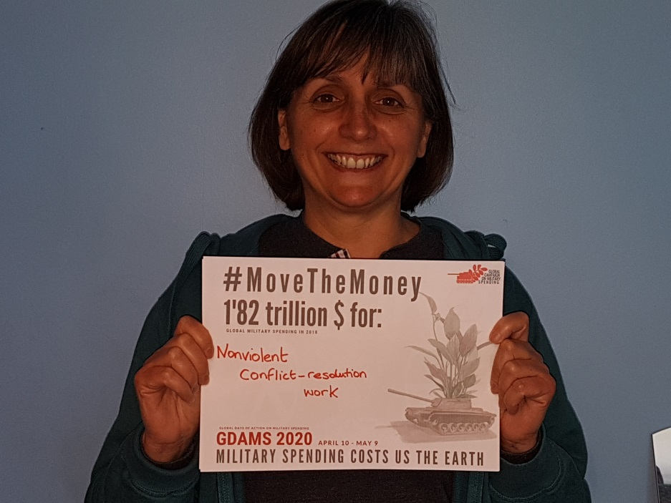
GDAMS infographic to download and print: http://demilitarize.org/resources/movethemoney-selfie-campaign/
Or make your own poster. Words are enough, but be as creative as you like!

