The Catholic Universe | Friday 5th June 2020
07

News

Investments is new frontline in fight against nuclear weapons

Public risks losing parks post-Covid
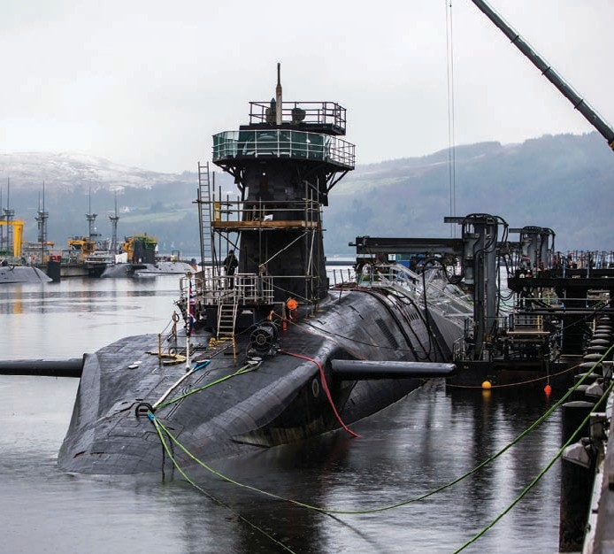
Hundreds of thousands of people could lose their local green space in
NHSVigilant, one of the Royal Navy’s Trident-missile carrying submarines. The new report highlights investments in businesses with links to the nuclear weapons industry

A new survey of UK pension funds and banks has revealed that billions of pounds are invested in companies that are producing nuclear weapons, meaning supporters of nuclear dis- armament may be unwittingly sup- porting the deadliest arms industry. The report, entitled ‘Banks, Pensions and Nuclear Weapons: Investing in Change’ , presents the results of a sur- vey of UK banks and pension funds and their financial links to companies
producing nuclear weapons. Baroness Sue Miller, co-president,
Parliamentarians for Nuclear Non- Proliferation and Disarmament, opened the report, noting that nuclear weapons states will spend at least $1 trillion on nuclear weapons over the next ten years.
She said: “Today, many financial institutions express their desire to be a force for good in society but may not realise that their loans and in- vestments finance the development of new nuclear weapons.”
Bishop Malcolm McMahon OP, na- tional president of Pax Christi British Section, said the report’s publication was a wake-up call for Catholics. “Pope Francis has written of building a ‘dif- ferent kind of economy: one that brings life, not death.’ This report looks ahead to when the Treaty on the Prohibition of Nuclear Weapons passes into international law. It high- lights that financial institutions may need to change their policy and prac- tice regarding investment in nuclear weapons, in order to comply with this important legal development.
“By acting on the information in this report, Christians can be at the forefront of this change.
“I encourage you to contact your bank and/or pension provider to dis- cuss your concern about any contin-

uing investment in nuclear weapons. ” He added: “In his World Peace Day message this year, Pope Francis re- minded us that peace ‘.. is a journey made together in constant pursuit of the common good, truthfulness and
respect for law.’ Theresa Alessandro, director at Pax
Christi, said the report is a vital con- tribution to helping push for nuclear disarmament through different routes: “Pope Francis says of nuclear weapons that ‘even their very possession is to be condemned’. This report provides us with the tools to enter into robust dialogue with the banks and pension providers we use.
“Pax Christi has been campaigning against nuclear weapons for decades. Now is a great time to be part of the

demand for change. A world without nuclear weapons is coming.”
The report, launched by the UK Nuclear Weapons Financing Research Group, which comprises researchers from a range of UK faith groups, details the group’s engagement with a sample of UK bank and pension providers to determine current policy and practice on investment in nuclear weapons.
The researchers note patchy aware- ness among executives of their or- ganisation’s record on nuclear weapons investment. Most companies score poorly but the report notes that some banks and pension funds have stated that they are actively reviewing this area.
In particular, the pension providers People’s Pension and NEST (the gov-
ernment’s default workplace pension scheme with 4.5 million members), said that they would seek the views of their members on investments in nuclear weapons producers.
The UN Treaty on the Prohibition of Nuclear Weapons will transform the way in which nuclear weapons are treated under international law, the report’s authors believe, and will directly affect the investment decisions of banks and pension funds in other countries. As an example, the PAX/ICAN Don’t Bank on the Bomb project has highlighted 36 major fi- nancial institutions that now have comprehensive exclusion policies, stopping any investment in businesses active in the nuclear weapons indus- try.
Robert Harrap of Buddhist organi- sation Soka Gakkai International-UK and member of the research group said “Just as the government has a choice over spending finite resources on health or on modernising nuclear weapons, so do we. We ask our banks and pension funds to invest in hu- manitarian causes that support life and health for the good of society.
“We don’t accept any rationale for our money being used in the devel- opment of weapons that threaten a devastation even greater than a global pandemic.”
Marigold Bentley, Quakers in Britain, said that: “All nuclear weapons treaties call for restraint and limitation, yet here we are in 2020 and our financial institutions continue to facilitate the nuclear arms race.
“This must stop and we need to hold banks and pension providers to account and demand change.”
To read the full report see moneyoutofnukes.wordpress.com/ read-the-report.
the next five years, a charity has warned, as it highlighted the impor- tance of parks for people’s health dur- ing the Covid-19 crisis.
Research from green space charity Fields in Trust, in partnership with the Co-op, analysed how future pop- ulation changes may impact parks and green spaces.
It estimated that 2.7 million people currently lived more than a 10-minute walk away from a public park, and this figure could increase by a further 170,000 in the next five years.
But the study suggests that the equivalent of 20,000 football pitches’ worth of green space could be lost in the next 20 years due to population growth.
Helen Griffiths, chief executive of Fields in Trust, said: “Parks and green spaces play a vital role in people’s health and wellbeing, and these ben- efits have been shown even more starkly during the really difficult times our country has faced in recent months.
“Our local parks and green spaces have been crucial during the crisis and they will have a significant part to play in our recovery. But we now run the risk of losing this precious re- source.”
Research from Fields in Trust sug- gests that the wellbeing value associ- ated with the frequent use of local parks and green spaces is worth more than £34 billion each year to the UK adult population.
It said regular park users visited their GP less often, resulting in a saving to the NHS of £111 million every year.
But the charity warned parks and green spaces were at “significant risk” of loss to development as it campaigns to protect them.

