Catholic Nonviolence Initiative – Spreading the Word and the Vision
Contacts and resources
Core Websites
Catholic Nonviolence Initiative: https://nonviolencejustpeace.net/
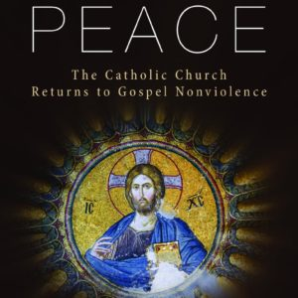
Pax Christi International : https://paxchristi.net/
Pax Christi England and Wales : https://paxchristi.org.uk/
Pax Christi Resources
Pax Christi E&W SHOP – range of resources to purchase https://paxchristi.org.uk/product-category/nonviolence/
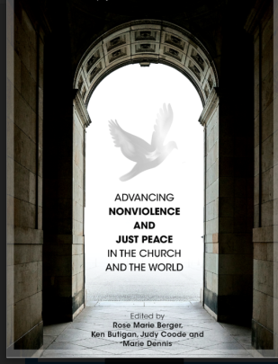
Choosing Peace: The Catholic Church returns to Gospel Nonviolence :
https://paxchristi.org.uk/product/choosing-peace-the-catholic-church-returns-to-nonviolence/
Coming soon! Advancing Nonviolence

On-line resources – Pax Christi E&W
The videos used today and many easy to access worksheets and other resources
can be found here
- https://paxchristi.org.uk/resources/nonviolence-in-action/educational-resources-for-nonviolence/
Nonviolence a Style of Politics for Peace – WPD message and support resources
- http://w2.vatican.va/content/francesco/en/messages/peace/documents/papa-francesco_20161208_messaggio-l-giornata-mondiale-pace-2017.html
- https://paxchristi.org.uk/news-and-events/peace-sunday/
Catholic Nonviolence Initiative Resources
- Appeal to Pope Francis – sign-up here https://docs.google.com/forms/d/e/1FAIpQLSdFx8hRZMEVpIpQL5zR2ln2AykAGCILlacVfuSGxzoMgpVyIA/viewform
- Making Active Nonviolence a Way of Life: reflections and questions for groups
https://nonviolencejustpeace.net/wp-content/uploads/2020/07/Making-active-nonviolence-a-way-of-life.pdf
Catholic Nonviolence Days of Action
- Background https://nonviolencejustpeace.net/days-of-action/
- Framework of ideas/approaches https://nonviolencejustpeace.net/wp-content/uploads/2020/06/Framework-to-celebrate-nonviolence.pdf

