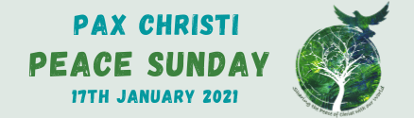
Quotations from the 2021 World Peace Day Message
A Culture of Care as a Path to Peace
- Peace, justice and care of creation are three inherently connected questions, which cannot be separated in such a way as to be treated individually …
- We need to stop and ask ourselves what has led our world to see conflict as something normal, and how our hearts can be converted and our ways of thinking changed, in order to work for true peace in solidarity and fraternity.

- How many resources are spent on weaponry, especially nuclear weapons, that could be used for more significant priorities such as ensuring the safety of individuals, the promotion of peace and integral human development, the fight against poverty, and the provision of health care.

- What a courageous decision it would be to establish a Global Fund with the money spent on weapons and other military expenditures, in order to permanently eliminate hunger and contribute to the development of the poorest countries.

- There is… a need for peacemakers, men and women prepared to work boldly and creatively to initiate processes of healing and renewed encounter.

- … may we strive daily, in concrete and practical ways, to form a community composed of brothers and sisters who accept and care for one another.

- … everything is interconnected and genuine care for our own lives and our relationship with nature is inseparable from fraternity, justice and faithfulness to others.

- … the need for relationships between nations to be inspired by fraternity, mutual respect, solidarity and the observance of international law.

- At a time like this, when the barque of humanity, tossed by the storm of the current crisis, struggles to advance towards a calmer and more serene horizon, the "rudder" of human dignity and the "compass" of fundamental social principles can enable us together to steer a sure course.

More resources here: https://paxchristi.org.uk/peace-sunday-2021/
Full message here: http://www.vatican.va/content/francesco/en/messages/peace/documents/papa-francesco_20201208_messaggio-54giornatamondiale-pace2021.html

