Ash Wednesday Service, online 17th February 2021 at 7pm
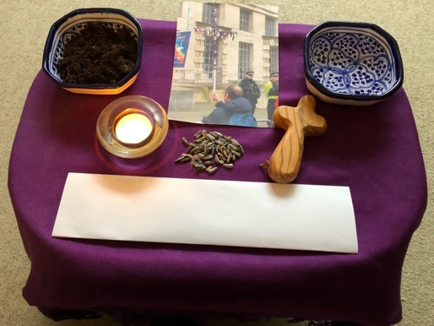
To take part in the Ash Wednesday Service you may like to gather the following things which will take the place of the symbols we usually use on our Ministry of Defence Walk:
- A cross;
- A candle;
- A small dish of soil;
- A small dish or jug of water;
- Some seeds – either from the pack you have been sent or some of your own;
- Piece of paper or cloth on which to write REPENT
- Piece of paper on which you have written the name of a place or person who has suffered in war and conflict that you would like to pray for

Zoom – please note the following hints:
- You will have received a Zoom link when you registered, if you have not received a link please contact Russell Whiting on CCNDdevelopoment@cnduk.org
- The service will be recorded – if you don’t wish your picture to be shown, then please turn off your camera;
- The Chat will be not be available during the service.
- Everyone will be muted during the service – please only unmute yourself if you are a Reader.
- During the service we will all hold up our paper with the name of the place of person we would like to pray for – a screen shot will be taken. If you don’t want to be seen then please hide behind your paper!

Ash Wednesday Service, online 17th February 2021 at 7pm
To take part in the Ash Wednesday Service you may like to gather the following things which will take the place of the symbols we usually use on our Ministry of Defence Walk:
- A cross;
- A candle;
- A small dish of soil;
- A small dish or jug of water;
- Some seeds – either from the pack you have been sent or some of your own;
- Piece of paper or cloth on which to write REPENT
- Piece of paper on which you have written the name of a place or person who has suffered in war and conflict that you would like to pray for

Zoom – please note the following hints:
- You will have received a Zoom link when you registered, if you have not received a link please contact Russell Whiting on CCNDdevelopoment@cnduk.org
- The service will be recorded – if you don’t wish your picture to be shown, then please turn off your camera;
- The Chat will be not be available during the service.
- Everyone will be muted during the service – please only unmute yourself if you are a Reader.
- During the service we will all hold up our paper with the name of the place of person we would like to pray for – a screen shot will be taken. If you don’t want to be seen then please hide behind your paper!

