Activity – Bread not Bombs
Organising a Bread Baking Workshop
Many communities suffering from violent conflict now are deeply attached to the whole culture around preparing and sharing traditional foods. Baking bread is often fundamental for daily living. But that is all at risk, when ordinary life is completely disrupted and desperate people flee their homes to often insecure shelter.
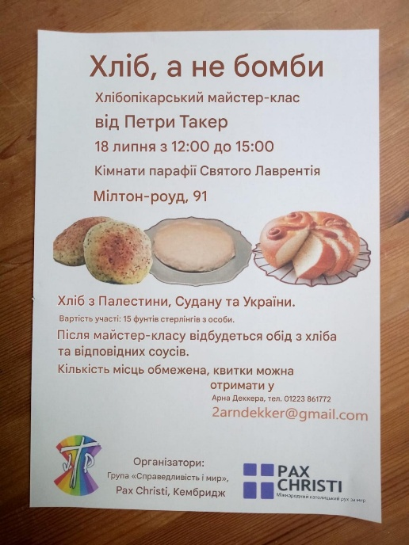
Recently in Cambridge, a baking workshop tried to recognise this loss as a different way of paying attention better to the realities inflicted by war on ordinary people, especially women. It was definitely intended to be a hands-on experience, discovering a variety of breads from Ukraine (Pampuska), Palestine (Taboon) and Sudan (Garusa). Led by an experienced, patient baker, a small group first learned to make dough and then bake some flat breads on a griddle (from dough prepared earlier by the leader). Afterwards, everyone shared a simple meal of breads and delicious appropriate dishes from the three countries. Our meal began with a prayer, adapted from the “Our Father” naming the different breads. At the end we left with a bowl of Taboon dough to bake at home and share with family or friends.
Why this activity?
It was poignant – ‘Eating the types of bread that many in those countries are not able to, pulls us up sharply.’ Such thoughts can prompt us to engage more thoughtfully with current reports from war-torn countries. Displays had been prepared about the situation in Ukraine, Palestine and Sudan using reliable sources of information. Ideally, there is opportunity to discuss aspects of this together, but at least copies can be circulated to everyone to reflect on later.
Prepare for the event
You need to adapt this model of a baking workshop according to your local situation and be realistic about the maximum number of people. They need to buy tickets in advance to allow for proper planning and to cover the cost of ingredients etc. Timing is obviously important – as a guide, the Cambridge workshop lasted 3 hours, and the baker estimated spending 10 to 12 hours on all the preparations.
What you need
- an experienced baker (willing to be generous with their time to prepare as well as lead the workshop)
- choose which conflict(s) to focus on (only one would be fine)
- kitchen (with hob or oven depending on the type of bread)
- adjacent room with plenty of table space ready for mixing & kneading dough
- baking utensils (best to ask each person to bring their own bowl, small water jug & cutlery)
- bread recipes from the chosen country(ies) (quite easily found online)
- ingredients (preferably measured beforehand ready for each participant to save time)
- some appropriate dishes to eat with the bread.

What we learnt
Alongside learning about baking bread, there is the aim of encouraging greater awareness of the real impacts of conflict. This could be done in different ways at the event itself – as well as information displays, perhaps a short talk would stimulate more questions and discussion. (This, of course, requires significant preparation time beforehand.)
Hopefully, people can leave not only with a bowl of dough, memories of a convivial time together, but also better equipped to explore the issues further, listening and paying attention differently.

Thanks to the Cambridge Pax Christi group for this great idea.
I can imagine various ways that others may find to adapt the activity. To start with, be less ambitious and focus on only one conflict. Some may think of simplifying things by making it a baking demonstration rather than a really hands-on workshop, but 'watching' is a very different experience from 'doing it yourself'! Perhaps it helped me in a small way to feel how baking bread is such a vital part of life for Palestinian women.
Looking back on our event and some of the feedback Arn got, I think there's more of a challenge in finding a sensitive and constructive way to combine the baking and sharing a meal in the same event as effectively learning more together about the realities of living through violent conflict. So my attempt at a guide is only a starting point......
Sheila Brookes

