Activity – Praying with the Vow of Nonviolence
Every year Pax Christi and the Catholic Nonviolence Initiative invite people around the world to read, reflect on and if they wish, rededicate themselves to the Vow for another year.
This activity could be a family or group activity in the days before 2 October, International Day of Nonviolence. Cards with the Vow can be ordered from the Pax Christi office.
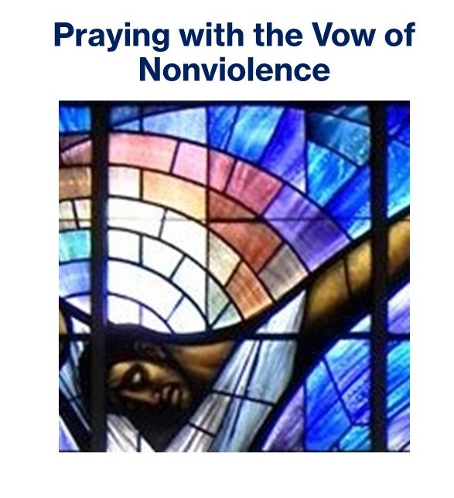
- Make copies of the Vow available to people in the group. Explain that together, you will use this to reflect on its meaning for each one of you.
- Invite two people to read: one for the introduction and one for the vow itself.
- Perhaps the five ‘calls’ of the Vow, beginning ‘by’ could be a focus for their reflection – which do they find most attractive or relevant to their lives?
- Keep a short time of silence
- Invite people to share the thoughts that have come to them when reflecting on the Vow. Could you create a ritual or prayer service around making the Vow?

Vow of Nonviolence
Recognising the violence in my own heart, yet trusting in the goodness and mercy of God, I vow to practice the nonviolence of Jesus who taught us in the Sermon on the Mount:
“Blessed are the peacemakers, for they shall be called the sons and daughters of God… You have learned how it was said, ‘You must love your neighbor and hate your enemy,’ but I say to you, ‘Love your enemies, and pray for those who persecute you. In this way, you will be daughters and sons of your Creator in heaven.”
I vow to carry out in my life the love and example of Jesus
by striving for peace within myself and seeking to be a peacemaker in my daily life;
by refusing to retaliate in the face of provocation and violence;
by persevering in nonviolence of tongue and heart;
by living conscientiously and simply so that I do not deprive others of the means to live;
by actively resisting evil and working nonviolently to abolish war and the causes of war from my own heart and from the face of the earth.
God, I trust in Your sustaining love and believe that just as You gave me the grace and desire to offer this, so You will also bestow abundant grace to fulfill it. Amen.

