Activity - Talking Points on Nonviolent Peace-making
This could be used in a group to start a discussion on nonviolence.
- Make a copy of the statements below. You can add ideas of your own.
- Cut them up and fold them in quarter. Put then in a container a, jar, bag or bowl.
- Pass the container around the group, inviting each person to take a piece of paper and read it.
- After a minute or so, invite them to share their statement and their response with their neighbour and vice versa.
- When you feel it is right, invite those who wish to share something of their discussion.
- At the end, ask if people have had their understanding of nonviolence expanded in any way.


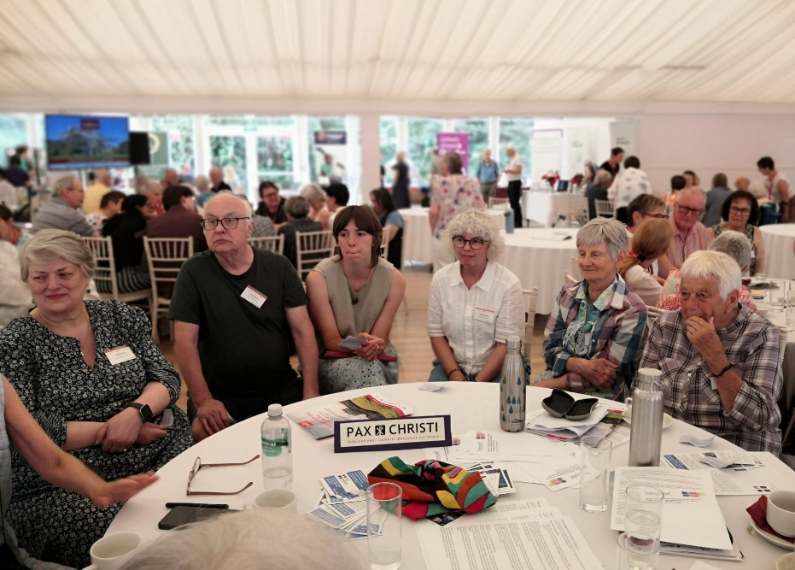

A talking point jar

A group discussing their statements, taken from the bag in the centre of the table.

Nonviolence, as a method and a style, must distinguish our decisions, our relationships and our actions. …  It is essential for disarming hearts, approaches and mentalities, and for denouncing the injustices of a system that kills and is based on the throwaway culture. Pope Leo | It will not trouble us to be deemed naïve for choosing peace. Pope Francis  What do you think?
Why do you think the teachings of popes on peace and nonviolence not seem to reach many Catholics and be integral to their faith? | Jesus did not just preach nonviolence, he lived it. He stopped a killing with a word. He told Peter to put down the sword.  Where else do we see Jesus live nonviolence?
The goal of nonviolent action is not to repress or defeat, but to convert…allowing the ‘enemy/other’ to live according to the better part of human nature.  Have you ever experienced something like this? | In Magnifica Humanitas Pope Leo suggests that we all have our own areas for action where we must choose whether to fuel the mentality of force (even if only through lies, indifference, hatred...) or preserve the mindset of peace (with truth, moderation, care…)  Where is your main area/sphere for action?
How do we live and share peace and nonviolence with those in our society supporting the far-right, and peacefully oppose them?  Do you have experience in attempting to do this? | Nonviolence is not for cowards. It calls for deep inner strength, the strength of self-control, maintaining respect for oppressors… the nonviolent person does not simply quiet down when trouble starts but stands up and faces the difficulty.  Have you ever experienced something like this?
Is it important that it can be empirically proved that nonviolence is more effective than war and conflict or does the Gospel call us to be nonviolent regardless?  What do you feel? | In the midst of the many challenges facing our world … armed conflict, division among peoples, the challenges of forced migration and so forth, the efforts to promote nonviolence are all the more necessary. Pope Leo.  What do you think of this?
A nonviolent person tries to comfort the afflicted but also to afflict the comfortable. The intent to speak truth to power is not to cause distress, but to expose the complicity with violence.  Exposing violence is a first stop to  overcoming it. What means do we have to expose violence? | Where is the balance between learning about and contemplating peace and nonviolence, and seeking to actively build a kingdom of peace, justice and love?  How do we hold the personal and the public/community?
Do we need to remember we are seeking a better world and not expecting a perfect world through our efforts?  What do you think? | Nonviolence is not weakness. It is deliberate, organised, faithful. It is a style, a revolution of hope for our world.
Extreme natural phenomena caused by climate changes provoked by human activity are growing in intensity and frequency (cf. Laudato Deum, 5), to say nothing of the medium and long-term effects of the human and ecological devastation being wrought by armed conflicts.  How might active nonviolence address some of this devastation? | The three big challenges of our time are climate breakdown, the global economic system and militarism. Prof Paul Rogers  Are these your ‘Big Three? Do you see any connections between them?

