How to get to Pax Christi at St Joseph’s, Watford Way, Hendon, London NW4 4TY. Though the postal address is Watford Way, the entrance for visitors/cars is via St Joseph’s Grove.
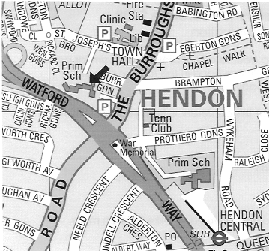
Entrance:
via St Joseph’s Grove
off The Burroughs

Tube:
Northern Line to
Hendon Central, then
a 10-minute walk

Buses:
143, 183, 326 stop at ‘Hendon Town Hall’ in
The Burroughs; 113, 186, stop at ‘Hendon War Memorial’ on Watford Way

Visitor parking:
Very limited on site. Payment bays on Joseph’s Grove, and in car parks off
The Burroughs

Finding the Pax Christi office

Go to Hendon Central on the Northern Line. Walk uphill to the war memorial, and turn right along The Burroughs. Turn left into St Joseph's Grove, and left again into the school drive (about 10 minutes’ walk from the tube).
You will see the primary school entrance ahead (see photo) and chapel on its right. Walk round the right-hand side of the chapel, along past the dustbins, and in the corner is the door you want. The Pax Christi bell is at the top left.

